Broadland High Ormiston Academy Uniform Policy

Aims:
- To unify our students in a smart collective dress code.
- To create a shared identity based around pride in attending Broadland High.
- To ensure our students are ‘ready to learn’ and not distracted by clothing.
- To avoid inappropriate clothing on the academy site.
- To avoid discrimination based on clothing or fashion.
- To reduce pressure on parents to buy the latest fashions.
- To prepare students for the uniformed world of work.

Academy Uniform Overview
We believe that it is important for all our students to maintain a smart appearance in our academy.
We therefore expect all students to adhere to the following dress code.

Uniform Item | Expectation | Additional Information
Blazer | KS3 - Green blazer with academy badge  KS4 - Black blazer with academy badge | - Only academy issued badges to be worn on blazers e.g. Prefect badge  - Blazers are to be worn at all times in academy and should only be removed with the permission of the teacher  - Blazers can be removed whilst playing on the hardcourts/field during breaktime and lunchtime, which should be put back on before leaving that area
Jumper  (Optional) | KS3 - Green V neck with academy badge  KS4 - Black V neck with academy badge | - Should only be worn under the blazer  - Should not be worn instead of the blazer
White Shirt | With collar and top button | - Top button fastened at all times  - Short sleeved shirts can be worn in the summer  - Long enough to be tucked in properly at all times  - Plain (no frills or logos)
Tie | Year group striped tie | - Length of x12 stripes visible
Footwear | Plain black leather or synthetic leather footwear | - Students are allowed to wear black, leather (or synthetic leather) footwear with black soles and no other evident colours, markings or visible branding.  - No boots unless extenuating circumstances linked to injury or support have been agreed  - Footwear should be polished  - No coloured logos, edging or laces  - No heels
Coat  (Optional) | Suitable and appropriate coat | - Should not be worn under or in place of the blazer  - No ‘hoodies’ or non-academy jumpers at any time  - Not to be worn inside the building
Jewellery | Watch (Not a Smartwatch)  One stud per ear lobe | - No facial/body piercings  - No body artistry (includes Henna)  - No spacers or stretchers or clear retainers in unauthorised piercings  - No rings, necklaces or bracelets (medical alert items are permitted)
Hair | Natural hair colour | - No patterns, extreme styles/colours  - Hair accessories such as hair clips, alice bands and ‘scrunchies’ must not be large or brightly coloured
Trousers | Black or charcoal grey trousers  (The badged trousers are strongly advised) | - Straight, bootleg or wide leg trousers only  - No ‘skinny’ trousers, chinos, cropped, canvas or jean materials  - No visible zips or rivets  - It is strongly advised that the ‘badged’ trouser is purchased. This can be purchased from Birds of Dereham
Belt  (Optional) | Dark plain belt | - No brightly coloured belts  - Small buckle with no logos
Socks | Dark socks | - No patterns or logos
Skirt | Black knee length pleated or straight skirt  (The badged skirt is strongly advised) | - Skirts must be no more than one hands width above the knee, ideally worn on the knee  - Skirts must not be skinny, tight Lycra or made of stretchy material  - It is strongly advised that the ‘badged’ skirt is purchased. This can be purchased from Birds of Dereham
Tights | Plain black or flesh coloured
Makeup and Nails | No visible makeup | - Clear nail varnish only  - Nails should be of a sensible length  - No false nails

Physical Education
Black polo shirt with academy logo |  | In addition, optional items:
Black shorts or black sports tights  If shorts are lycra they should be mid-thigh length |  | Black tracksuit bottoms (optional for when the weather is cold)
Sports socks for indoors
Black football socks for outdoors
Trainers |  | Black BHOA sweatshirt with Academy logo for cold weather
Football boots
Shin pads |  | BHOA reversible rugby shirt
Gum shields are recommended for hockey and compulsory for contact rugby
Drama: Grip socks to change into

- All articles of clothing and personal belongings must be clearly named
- Ties can be purchased from the Broadland High academy office

- Birds of Dereham
UNIT D 13 YAXHAM ROAD, DEREHAM, NORFOLK NR19 1HB. enquiries@birdsofdereham.com
+44 (0) 1362 692941 +44 (0) 1362 699130

Electronic devices not permitted in school:
Mobile phones, smart watches, headphones, speakers and MP3 players are not allowed to be seen on the academy site (NB: the academy does not take any responsibility for such items). They may be used on the way to and from the academy but must be turned off and put away in bags before the student enters the site and must not be taken out until the student has left the academy site.
Further information and guidance:

Shoes:
- Students are allowed to wear black, leatheror synthetic leather footwear with black soles and no other evident colours, markings or visible branding. (No coloured logos or edging).
- No heels

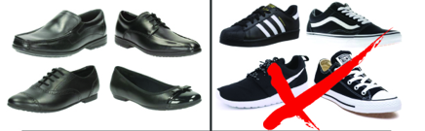

Skirts:
- Skirts must be no more than one hand’s width above the knee
- Skirts must not be skinny, tight lycra or made of stretchy material
- It is strongly advised that the ‘badged’ skirt is purchased. This can be purchased from Birds of Dereham
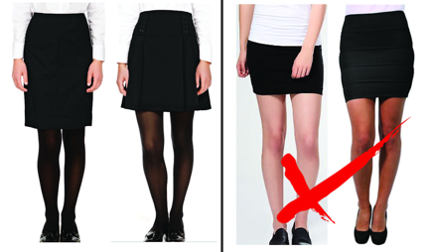

Trousers:
- Straight, bootleg or wide leg trousers only
- No ‘skinny’ trousers, cropped trousers, chinos, canvas or jean materials
- No visible zips or rivets
- It is advised that the ‘badged’ trouser is purchased. This can be purchased from Birds of Dereham
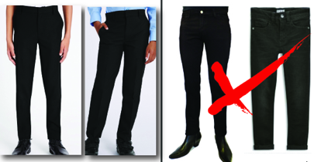

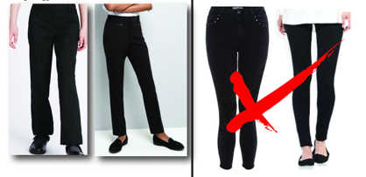
Equipment:
In addition to their academy uniform, we expect all students to be well prepared for learning and arrive to all their lessons with a set of basic classroom equipment that should consist of:

- Pens (black)
- Pencil
- Ruler
- Eraser
- Reading book
- Scientific Calculator
- Protractor
- Pair of compasses
- Planner
- Sensible bag
- Knowledge Organiser (will be provided)

Additional items strongly recommended:
- Colouring pencils
- Glue Stick
- Please do not pack scissors in pencil cases as they can be considered a dangerous item. Scissors will be provided in lessons when required.

