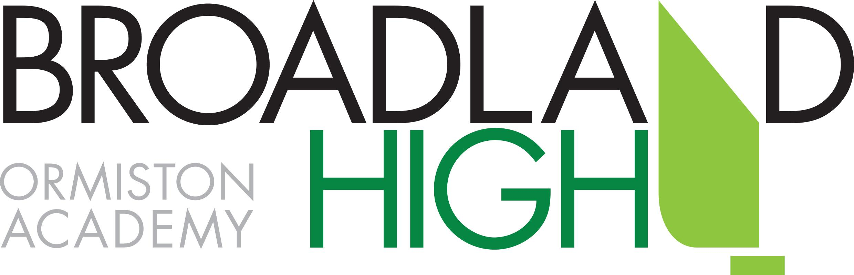
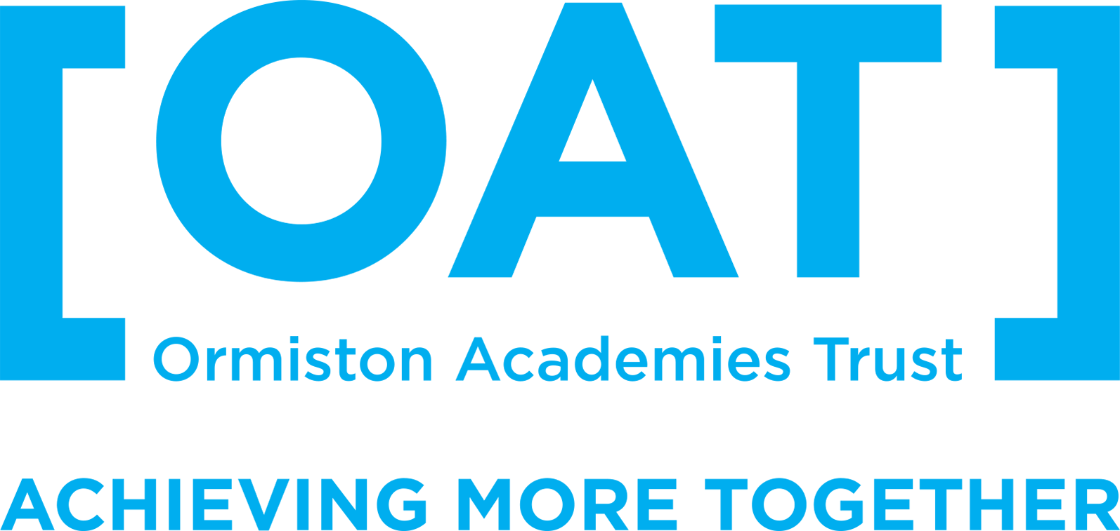

Broadland High Ormiston Academy
Curriculum Policy
This document should be read in conjunction with the OAT Curriculum Statement, which forms the basis of the academy curriculum policy.
Aim of the Curriculum
At Broadland we aim to provide a curriculum personalised to the needs and interests of all our students, enabling them to fulfil their potential and inspiring them to further study and lifelong learning. We believe that the curriculum, both within taught lessons and beyond them, should create an environment where questioning, academic risk-taking and the freedom to learn from mistakes are all encouraged. We intend that our curriculum should imbue in our students these qualities: responsibility, independence and a sense that learning can be exciting and valuable throughout life. Educational visits form an important part of the school curriculum and are covered under a separate policy.
We follow the National Curriculum. The academy meets all statutory obligations for PSHE (including Sex Education), Citizenship, RE and Careers Education through discrete timetabled lessons in KS3 and 4, educational visits and the use of external providers (for example to provide impartial careers advice). Qualifications offered must be approved by OFQUAL and in the vast majority of cases will also be approved to count on the school performance tables.
Cross-Curricular Links and Skills
All subject areas produce an annual “big picture” summary of their curriculum plan, which is shared with other heads of department in order to identify repetition, gaps or issues with sequencing.
SMSC and Fundamental British Values
We have a duty to promote the social, moral, spiritual and cultural development of all our students. SMSC figures in all subjects and in many other aspects of school life, such as tutor time, assemblies, educational visits and opportunities for student leadership. Effective SMSC education is critical in preparing our students for the future, instilling resilience and developing a lifelong love of learning. Through our SMSC provision we actively promote the fundamental British values of democracy, the rule of law, individual liberty, and mutual respect and tolerance of those with different faiths and beliefs.
Literacy
We aim for all of our students to become literate and articulate communicators. In all subjects, pupils should be taught to express themselves correctly (in full sentences) and appropriately on paper and orally, and to read accurately and with understanding. Students who arrive at Broadland below the nationally-set standard for English will receive a programme of intervention to address their needs. One group in Year 7 and Year 8 follows an adapted curriculum, led by expert staff, to build a strong foundation for these students in reading and writing so they can flourish in Year 9 and at KS4. The group does not study MFL in Y7, instead having more time for English and the Humanities, and to receive study support sessions to pull together and practise the vocabulary and techniques learned across the curriculum. In Y8 the group takes German but not French, leaving 3 periods per fortnight available for English and study support. The staff handbook contains guidance for teachers on embedding literacy within their lessons.
In writing, pupils should be taught to use correct spelling and punctuation and follow grammatical conventions. They should also be taught to organise their writing in logical and coherent forms. In order to develop as writers, students must be given opportunities to write at length in a range of subjects, and using previously unseen texts and sources as stimuli. When writing, students should be taught to identify the audience and purpose for their work (and genre, where appropriate).
Oracy is an important aspect of the curriculum. In speaking, pupils should be taught to use language precisely and cogently. Pupils should be taught to listen to others, and to respond and build on their ideas and views constructively.
In reading, pupils should be taught strategies to help them read with understanding, to locate and use information, to follow a process or argument and summarise, and to synthesise and adapt what they learn from their reading. They should be specifically taught strategies to aid revision, including how to retain information long-term for deep understanding. Reading for pleasure is embedded in the study programme, in tutor time and encouraged through the use of programmes such as Accelerated Reader.
Numeracy
Similarly, all subjects are responsible, where appropriate, for developing students’ numeracy when opportunities arise during the course of the lessons. This can be done through asking students to use mental maths, basic mathematical formulae, tables and graphs to present data, and estimates and calculations. The numeracy group identified a number of standard techniques and agreed a shared language to be used across subjects, which can be found in the staff handbook.

Use of ICT across the Curriculum
Pupils should be given opportunities to apply and develop their digital literacy through the use of ICT tools to support their learning in all subjects, supported by the KS3 Computing curriculum delivered through discrete lessons.
Curriculum Organisation, including Options
- The academy operates a 2-week timetable, composed of 50 periods of one hour in length. Allocations to each subject are reviewed in light of new demands (for example new GCSE specifications) and taking advice from the Trust and other organisations with which we work.
- In line with the government’s ambition for 90% of students to study the English Baccalaureate, the school will expect those students capable of achieving a 5 or better in all the Ebacc subjects to follow an Ebacc pathway at KS4. However, we believe that choice in what they study motivates students to do their best, so where there is a strong case for students to follow a more general pathway (for example to prepare them for their future career) there will be scope to do so. Similarly, no student will be barred from taking the English Baccalaureate. Option blocks are determined primarily each year by student preferences, but constraints such as rooming and staffing will also be taken into account. Similarly, it is not financially viable for very small options groups to run: the smallest group size will normally be 14 students, with smaller groups able to run at the Principal’s discretion if finance permits.
- Students may be grouped by (prior) attainment or in mixed-ability classes for some subjects. In both cases, it is necessary to block subjects together to facilitate timetabling. These links are discussed with relevant heads of department before the production of the curriculum model. Where setting is used, groups will be defined by a lead subject (usually English or Maths) in consultation with linked subjects. Setting is based on attainment. In year 7, KS2 results will be used as the basis for setting decisions, but beyond that, heads of department must use robust assessment data to justify set changes. Where students have achieved the same level of attainment, decisions can be made using estimated future performance from FFT or other organisations, along with teachers’ professional judgement. Group changes affect all linked subjects and can disrupt learning, so they will usually occur only at agreed points in the year. Occasional group changes may be necessary at other times, for example when a new student joins the school.

Study
We believe independent study is a vital component in a successful education. In many cases this will involve students memorising important concepts and definitions from subject-specific Knowledge Organisers, reading for pleasure or practising techniques and skills (for example using online services in Maths and MFL). Study Tasks may take different forms, for example extended, project-based tasks as well as shorter exercises. Study is covered under a separate policy, which sets out the expectations for each subject in each year group.
SEN-D
At Broadland High we believe in participation for all. We want all adults and children to participate in learning and we celebrate all members of our community. We want to create an inclusive culture in our school and we aim to be more responsive to the diversity of children’s backgrounds, interests, experience, knowledge and skills.
Every teacher is required to adapt the curriculum to ensure access to learning for all children in their class. The Teacher Standards 2012 detail the expectations on all teachers.
Our teachers will use various strategies to adapt access to the curriculum, this might include using:
- Visual timetables
- Writing frames
- Chromebooks, laptops or other alternative recording devices
- Peer buddy systems
- Positive behaviour rewards system
Each learner identified as having SEN, is entitled to support that is ‘additional to or different from’ a normal differentiated curriculum. The type of support is dependent on the individual learning needs, and is intended to enable access to learning and overcome the barrier to learning identified. This support is described on a provision map, which although does not detail the individual learner names, describes the interventions and actions that we undertake at Broadland High School to support learners with SEN across the year groups. We modify the provision map regularly, and it changes every year, as our learners and their needs change. Further details of the special educational provision programmes we offer are available in our SEN information report on the school website.
Sharing our curriculum
Parents have an important role to play in supporting their children’s learning, so our curriculum maps for each subject and year group, showing not just content but how parents can support their child, are published on the school website and updated annually.

