Ormiston Academies Trust
Broadland High Ormiston Academy
Provider Access Policy Statement (PAL)

Access for colleges, training providers, universal technical colleges, universities, and all other post-16 providers, including technical, vocational, and academic routes and apprenticeships.

Policy version control
Policy type | Statutory, OAT Mandatory template
Author | Klara Reddy. Senior LP for Personal Development  Rachel McCarthy, National LP for Enrichment
Approved by | Executive, January 2023
Trust Board approval | 9th March 2023
Release date | January 2023
Review | Policies will be reviewed in line with OAT's internal policy schedule and/or updated when new legislation comes into force
Description of changes | This is a new policy to reflect to the changes to the Provider Access Legislation coming into force in January 2023.

Contents
1. Introduction 3
2. Pupil entitlement 3
3. Management of Provider Access Requests 5
3.1. Procedure 5
3.2. Opportunities for access 6
3.3. Previous pupil destinations 8
4. Premises and facilities 9
Appendix 1 10
Exemplar for academy internal guidance only 10

- Introduction
  - Broadland High Ormiston Academy is committed to supporting our students to make informed decisions about their future pathways. We act impartially, in line with our statutory duties, to ensure that we promote a full range of academic routes, technical routes and apprenticeships. We believe that it is vital to ensure that all pupils are aware of the benefits of apprenticeships, T levels and other approved technical qualifications and can consider them, alongside academic options, when making decisions about their next steps.
  - This policy statement sets out the school’s arrangements for managing the access of providers to pupils at the school for the purposes of giving them information about the provider’s education or training offer. This complies with the school’s legal obligations under Section 42B of the Education Act 1997, the legal duty known as the ‘Baker Clause’, 2018 and the Skills and Post-16 Education Act 2022.
  - The quality and impact of careers provision at Broadland High Ormiston Academy is monitored by our Senior Leadership Team, the National Lead Practitioner Enrichment Careers and OAT. Access and opportunity to engage with technical, vocational, and training providers will form part of this process.
- Pupil entitlement
  - Meaningful provider encounters
    - One encounter is defined as one meeting/sessions between pupils and one provider. We are committed to providing meaningful encounters to all pupils using the Making it meaningful checklist. Making it Meaningful: Benchmark 7 | CEC Resource Directory (careersandenterprise.co.uk)
    - As part of our careers programme, we will consider requests from approved training, apprenticeship, technical and vocational educational providers, including University Technical Colleges where appropriate, to speak to our students. Broadland High Ormiston Academy will also approach these providers directly when planning and organising key career related events throughout the school year, such as school assemblies, webinars within the curriculum, including live events, careers management events and parents' evenings.
  - Pupil entitlement
    - The Baker Clause is legally enforceable, and our academy is committed to meeting its requirements. All pupils in years 8 to 13 are entitled:
- To find out about technical education qualifications and apprenticeships opportunities, as part of a careers programme which provides information on the full range of education and training options available at each transition point
- To hear from a range of local providers about the opportunities they offer, including technical education and apprenticeships – through options events, assemblies and group discussions and taster events
- To understand how to make applications for the full range of academic and technical courses
    - Minimum Frequency and key stage
    - All pupils are entitled access to post-16 providers on a minimum of two occasions during each of the first, second and third key phases of their education.
    - In line with the updated Provider Access Legislation, from January 2023, all schools must provide a minimum of six encounters for all students with post 16 providers, as above. This is broken down into key phases.
    - We define the phases as:
    - First key phase: the period beginning at the same time as the school year in which the majority of pupils in the pupils’ class attain the age of 13 and ending with 28 February in the following school year (Year 8 and between 1 September and 28 February during Year 9)
    - Second key phase: the period beginning at the same time as the school year in which the majority of pupils in the pupils’ class attain the age of 15 and ending with 28 February in the following school year (Year 10 and between 1 September and 28 February during Year 11) and
    - Third key phase: the period beginning at the same time as the school year in which the majority of pupils in the pupils’ class attain the age of 17 and ending with 28 February in the following school year (Year 12 and between 1 September and 28 February during Year 13)
    - For pupils of compulsory school age these encounters are mandatory for all to attend and there will be a minimum of two encounters for year 8 to 9 pupils and two encounters for year 10 to 11 pupils. For pupils in year 12 to 13, particularly those that have not yet decided on their next steps, there are two more provider encounters available during this period, which are optional for pupils to attend.
2.2.2 Content of the provider encounters
    - We ensure that each registered pupil meets with a representative range of education and training providers to whom access is given and that the providers will provide the following set of prescribed information, as a minimum:
    - Information about the provider and the approved technical education qualifications or apprenticeships that the provider offers;
    - Information about the careers to which those technical education qualifications or apprenticeships might lead;
    - A description of what the learning or training with the provider is like; (including the opportunity to meet staff and students from the provider) and
    - Responses to questions from the pupils (including our most vulnerable and those with additional learning needs) about the provider or technical education qualifications and apprenticeships.
    - Where practical, our registered students will have access to a university technical college
    - Broadland High Ormiston Academy defines an encounter as at least 1 hour during the academic day.
- Management of Provider Access Requests
  - Procedure
    - A provider wishing to request access should contact Jay Roll. All requests made by providers should be emailed at least 6 weeks in advance of the expected date of the session.
- Telephone: 01603 782715 Email: jayroll@broadlandhighoa.co.uk
    - The academy will then work with providers to identify the most effective opportunity for them to share information about education and training opportunities. The Careers Leader will prepare for each provider visit by notifying students and their parents to consult the provider website for background information, including details of the courses and qualifications that the provider offers and their Ofsted grade.
    - Please complete this table and copy into an email to the Careers Leader (or create a link to a document)
Name of the provider requesting access &details of provision | e.g. ,Lakeside College, Further Education College, and Apprenticeship provider for 16–18-year-old students
Contact name at Provider and contact details | Name and Job title:  Email address:  Telephone number
Proposed date, time, and length of session
Number of staff who propose to visit | All visitors will be subject to our safeguarding policy. A DBS check will not be required.  BHOA Child Protection and Safeguarding Policy
Aims and objectives of session including year group | e.g., Year 10 assembly Post 16 Options including entry requirements, courses available, labour market information & sectors relating to courses, positive destinations on completion of courses.
Please demonstrate which Gatsby Benchmarks relate to the session and how (link to information re Gatsby Benchmarks Good Career Guidance | Education | Gatsby | e.g.,  BM1 After reading Careers Programme support to further enhance this  BM4 linking GCSE subjects to career related learning and future progression routes  BM7 Provide a meaningful encounter of further education
Proposed format, timings and duration of the session including facilities and equipment required | e.g., One hour assembly, theatre, or main hall to accommodate year group. PowerPoint presentation including videos. Questions and answers session for students. Literature to be taken away following assembly.
Support required from Broadland High Ormiston Academy including staffing | To enable the academy to provide appropriate supervision.
  - Opportunities for access
    - A number of events, integrated into the school careers programme, will offer providers an opportunity to come into school to speak to pupils and/or their parents. The academy will make provider visits available to all students in the relevant year group.
    - The Careers Leader will ensure that the level of access will be for a ‘reasonable period of time during the standard school day.’ The Academy Day runs from 8.30am until 3pm
    - The academy offers a comprehensive careers education programme. The academy is committed to working with other providers to ensure our pupils can make informed decisions about future choices. Where possible, we like to align visits with our programmed calendar of CEIAG (see below). Please speak to our named Careers Leader to identify the most suitable opportunity for you.
    - Once your request has been submitted, the Academy Careers Leader will respond to you within 10 working days. All requests will be given due consideration by the designated Careers Leader and Senior Leadership Team.
    - Once the request has been granted, we will ask you for a range of information to share with our pupils and parents before the session. This may include a prospectus, letter, or presentation.
    - This should include:
    - Details of the opportunities you offer including technical education, courses, and entry requirements.
    - What is the learning like in your institution?
    - How do you prepare students for their best next step on successful completion of your course/training?
    - Provide examples of linking courses with careers relating to the labour market and recent positive destinations of pupils who have completed their learning with you.
    - Requests will be considered against:
    - Clashes with other planned activities or visits
    - Interruption to preparation for public or internal examinations
    - Availability of school staff, space, and resources to host the session
    - All requests will also be considered in line with the academy's Safeguarding policy. For questions on this policy statement or the wider careers programme at Broadland High Ormiston Academy please do not hesitate to contact us.
    - Broadland High Ormiston Academy will keep a log of all provider requests for access and the outcomes and record on Compass+ to support delivery and evaluation of the careers programme.

 | Autumn Term | Spring Term | Summer Term
Year 8 | Assembly and tutor group opportunities | Visit from local Apprenticeship provider | Visit from local technical college
Year 9 | Assembly and tutor group opportunities | Assembly and tutor group opportunities  Options process | Assembly and tutor group opportunities
Year 10 | Assembly and tutor group opportunities | Assembly and tutor group opportunities  Careers and Skills Festival | Assembly and tutor group opportunities
Year 11 | Assembly and tutor group opportunities  Visits from a range of post-16 providers | Assembly and tutor group opportunities

    - The academy policies on safeguarding and visitors sets out the school’s approach to allowing providers into school as visitors to talk to our students. These can be found on the school website.
    - In previous terms/years we have invited the following providers from the local area to speak to our pupils:
- City College Norwich
- Access Creative Norwich
- Ask Apprenticeships
- UTCN
- Thorpe St Andrew Sixth Form

  - Previous pupil destinations
    - Last year our Year 11 pupils moved to a range of providers in the local area after school: 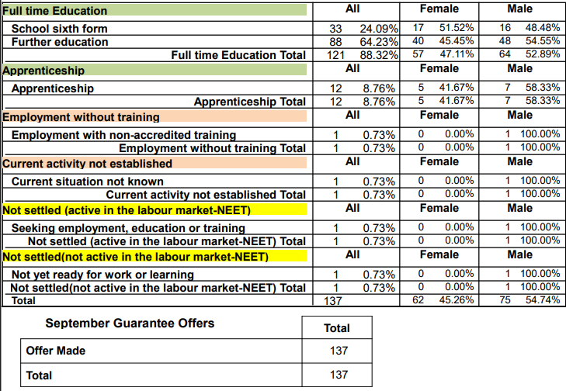
- Premises and facilities
  - The school will make the main hall, sports hall, classrooms or private meeting rooms available for discussions between the provider and students, as appropriate to the activity. The school will also make available projectors and other specialist equipment to support provider presentations. This will all be discussed and agreed in advance of the visit with the Careers Leaders or a member of the academy team.
  - Meaningful online engagement is also an option, and we are open to providers that are able to provide online engagement with our pupils.
  - Providers are welcome to leave or send a copy of their prospectus or other relevant course literature to the academy Careers Leader, who will ensure that this is placed in the appropriate careers area of the academy. This area is available to all students at break and lunch time.
  - If a provider wishes to raise a complaint with regards to provider access, this should in the first instance be directed to:
Name: Charlotte Trevatt Role: PA to Principal, HR Lead & Clerk to Governors
Telephone: 01603 777 879 Email: charlottetrevatt@broadlandhighoa.co.uk

