 | NB Modules may well continue over a half term into the next
 | Aut 1 | Aut 2 | Spr 1 | Spr 2 | Sum 1 | Sum 2
7 | Mental and Written Calculations  Geometrical reasoning (angles, coordinates, 2D shape, 3D shape) | Expressions, equations, formulae and identities  Place value, ordering and rounding integers, power and roots | Transformations  Fractions, decimals, percentages, ratio and proportion | Specifying a problem and interpreting data  Collecting and Representing data | Sequences  Construction, loci, measures and mensuration | Probability  Functions and Graphs
 | Number 1 Y7 MathsWatch links  Geometry 1 Y7 MathsWatch links | Algebra 1 Y7 MathsWatch links  Number 2 Y7 MathsWatch links | Geometry 2 Y7 MathsWatch links  Number 3 Y7 MathsWatch links | Statistics 1/2 | Algebra 2 Y7 MathsWatch links  Geometry 3 Y7 MathsWatch links | Statistics 3 Y7 MathsWatch links
8 | Mental and Written Calculations  Geometrical reasoning | Expressions, equations, formulae and identities  Place value, ordering and rounding integers, power and roots | Transformations  Fractions, decimals, percentages, ratio and proportion | Specifying a problem and interpreting data  Collecting and Representing data | Sequences  Construction, loci, measures and mensuration | Probability  Functions and Graphs
 | Number 1 Y8 MathsWatch links  Geometry 1 Y8 MathsWatch links | Algebra 1 Y8 MathsWatch links  Number 2 Y8 MathsWatch links | Geometry 2 Y8 MathsWatch links  Number 3 Y8 MathsWatch links | Number 3 continued  Statistics 1/2 Y8 MathsWatch links | Algebra 2 Y8 MathsWatch links  Geometry 3 Y8 MathsWatch links | Algebra 3 Y8 MathsWatch links  Statistics 3 Y8 MathsWatch links
9 | Mental and Written Calculations  Expressions, equations, formulae and identities | Geometrical reasoning (angles, coordinates, 2D shape, 3D shape)  Probability  Sequences | Fractions, decimals, percentages, ratio and proportion  Transformations | Place value, ordering and rounding integers, power and roots  Construction, loci, measures and mensuration | Functions and Graphs  Probability  Sequences | GCSE course starts (see screenshot below)
 | Number 1 Y9 MathsWatch links  Algebra 1 Y9 MathsWatch links | Geometry 1 Y9 MathsWatch links  Number 2 Y9 MathsWatch links | Algebra 3 Y9 MathsWatch links | Number 3 Y9 MathsWatch links  Statistics 3 Y9 MathsWatch links | Algebra 2 Y9 MathsWatch links  Geometry 3 Y9 MathsWatch links
10 | Foundation or Higher GCSE | See screenshot below for guide to content and dates
 | Support links are available in Microsoft Teams for each class.
11 | Foundation or Higher GCSE | See screenshot below for guide to content and dates
Higher GCSE topics taught in summer term at end of Y9

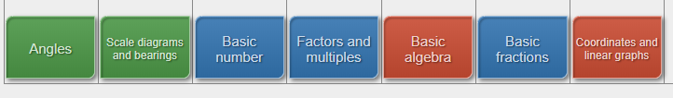
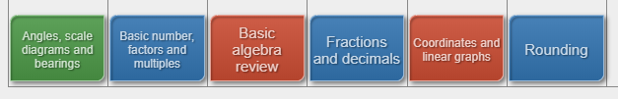

Foundation GCSE topics taught in summer term at end of Y9

