Special
Educational
Needs &
Disability
Information Report
06/09/2023

Introduction – (Clause 13)

Welcome to our information report which is part of the Norfolk Local Offer for learners with Special Educational Needs or Disability (SEND). The local offer provides information about the provision that is available from Education, Health and Social Care to help meet the needs of children and young people (0-25) with special educational needs and or disabilities. Norfolk’s local offer can be found at:

https://www.norfolk.gov.uk/children-and-families/send-local-offer

Our information report is updated at least annually with any changes to the information within it being made as soon as possible. Bold numbers in brackets refer directly to the relevant sections of the SEN Code of Practice 2015 whereas numbers in italics refer to the relevant clause on the Special Educational Needs and Disability regulations – schedule 1.

How does the academy implement its SEND policy? (6.79)

Our SEND policy is available on our website here:-

http://www.broadlandhighoa.co.uk/our-school/policies/

The governing body of Broadland High Ormiston Academy uses its best endeavours to ensure that the time, resources and personnel needed to fully implement our SEND policy are provided. This includes the appointment of an experienced and fully qualified special education needs and disability coordinator (SENCo) who only works at our academy and has sufficient non-contact time to carry out their role.

Our Head of Additional Needs and SENCo is Mrs Eleanor Gilroy and can be contacted either by telephone on 01603 782715 x 254 or by email at eleanorgilroy@broadlandhighoa.co.uk (clause 4).

What other policies do we have that make provision for pupils with special educational needs? (clause 3).

We have policies for/on: -

- Supporting students with medical conditions
- Admission arrangements
- Accessibility plan
- Equality duty
- Child Protection and safeguarding
- Behaviour for Learning
- Complaints Procedure
- Looked After Children

These policies are available at http://www.broadlandhighoa.co.uk/our-school/policies/

What is SEN and Disability?

A child or young person may be identified or diagnosed with a special educational need or disability at any time during their school career. The meaning of SEN and disability can be found on pages 15 - 16 of the SEN Code of Practice which is available at:-

https://assets.publishing.service.gov.uk/government/uploads/system/uploads/attachment_data/file/398815/SEND_Code_of_Practice_January_2015.pdf

How do we structure and adapt our Curriculum for learners with SEND? (6.82)

The Academy offers a broad and balanced curriculum for all its learners. Years 7 to 9 are known as Key Stage 3 and students study the core curriculum of English, Maths, Science, PE, Religion, Ethics and Philosophy and Personal, Social and Health education as well as a wide range of additional subjects including Design Technology, the humanities and modern foreign languages. In Key Stage 4 (Years 10 and 11) students follow a variety of accredited courses in both the core and optional curriculum. Students then take an additional 4 option subjects which include a variety of GCSE, and Cambridge Nationals to equip them for the next stage of their learning, training or employment.
We use various strategies to adapt access to the curriculum, this includes: -

- Smaller groupings (typically 15 rather than 28-30)
- High Quality Teaching Strategies (such as use of visualisers, modelling and scaffolding).
- Enlarged print,
- Use of coloured overlays,
- Literacy support group in Year 7 and 8,
- Use of Chromebooks, laptops and appropriate software/apps.
- Early release from lessons,
- Visual timetables,
- Time Out cards,
- Extra time,
- Temporary adjusted timetables (students with medical needs)
- Home Learning Support (students with medical needs)
- E-learning,
- Study support option instead of a GCSE,
- Entry Level Qualifications,
- Physical adaptations to the environment,
- GCSE Access Arrangements.

Our policy for GCSE Access Arrangements and Accessibility plan can be found here:-

http://www.broadlandhighoa.co.uk/our-school/policies/

What kinds of special educational needs do we provided for? (clause 1)

Children only have a special educational need if they need provision that is different from that available in the normal differentiated curriculum. Therefore, the more inclusive the core curriculum offer is the fewer the number of children with special educational needs will be. This is the case at Broadland High Ormiston Academy where we have identified from 757 pupils on roll, that 111 (13%) of children have SEND. Of these children 13 (12%) of these children have an Education Health and Care Plan (EHCP) and the remaining 88% are receiving SEND support.

The following chart shows the percentage of students in each year group by their primary SEN only, sometimes children have more than one need, and this is not shown.

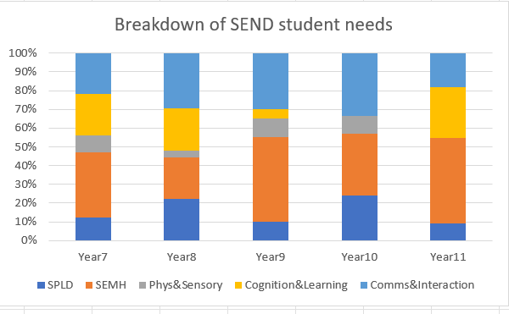

% Breakdown | Year7 | Year8 | Year9 | Year10 | Year11
SPLD | 12.5 | 22.2 | 10.0 | 23.8 | 9.1
SEMH | 34.4 | 22.2 | 45.0 | 33.3 | 45.5
Phys&Sensory | 9.4 | 3.7 | 10.0 | 9.5 | 0.0
Cognition&Learning | 21.9 | 22.2 | 5.0 | 0.0 | 27.3
Comms&Interaction | 21.9 | 29.6 | 30.0 | 33.3 | 18.2

The categories used in the chart are those we are required to use in the Government census; however, the SEN Code of Practice only has 4 categories.

Code of Practice Category | The total of:-
Cognition and Learning | Specific Learning Difficulty + Cognition and Learning
Communication and Interaction | ASD and Speech Language and Communication
Physical and Sensory | Physical and Sensory
Social, Emotional and Mental Health | Social, Emotional and Mental Health

How do we identify and assess if a child has special educational needs? (clause 2)

The needs of learners can change over time, a difficulty with learning may present as a child’s progress:-

- Being significantly slower than that of their peers from the same starting point.
- Failing to match or better the progress previously made.
- Failing to close or the gap widening between the child and their peers.

When a subject teacher notices a difficulty with learning, they will try different approaches in the classroom first to see if this makes a difference. At this point the teacher will contact the child’s parent/carer to share their concerns and the action they have taken.

Parents and students should discuss any difficulties with individual teachers in the first instance with the SENCo providing advice and guidance on curriculum adaptations during these initial stages.

Should the above actions not enable to student to make progress then a learning support assessment will be offered. The assessment will be personalised but is likely to include collecting information from teaching and support staff, classroom observation as well as the use of assessment tools.

The assessment tools used are decided on an individual basis but are usually selected from:

The Dyslexia Portfolio, WRAT 4, Single Word Reading/Spelling, Access Reading/Maths, Myself as a Learner, Strengths and difficulties questionnaire, Boxhall Profile, Progression Tools from the Communication Trust, SPaRCS, British Picture Vocabulary Scale and a range of assessments from GL.

Some of these assessments are standardised and are interpreted as described below:-

Standardised score | What this means | Further information
85 - 115 | The child is within the range expected for their age | Around 70 out of a 100 children.
84 or below | Below expected for age. | The child will qualify for GCSE Access Arrangements.  Approximately 15 children out of a 100.
116 or over | The child is above the range expected for their age. | Approximately 15 children out of a 100.

However, it is important to remember that these assessments can only provide a “snapshot” of a learner’s abilities as they can be influenced by other factors such as tiredness, illness and time of day.

If a learner has a significantly low score in a particular area this doesn’t always mean that they have SEN as learners can fall behind their peers for lots of reasons including:

- Poor attendance
- Many changes of school
- Adverse childhood experiences
- Speaking English as an additional language

Our SENCo will take the “whole picture” of the child into consideration before identifying the learner as needing SEN support. Please remember that further details are available in our SEND policy available here:-

http://www.broadlandhighoa.co.uk/our-school/policies/

What is our approach to teaching pupils with special educational needs and how do we find out if it is effective? (clause 3a,b and c)

All our teachers are responsible and accountable for the progress and development of all the students in their class. Therefore, the starting point of our approach to teaching learners with SEND is high quality teaching every lesson, every day. Our staff continually assess progress to ensure that learning is taking place and we actively monitor this by:-

- regular classroom visits,
- work scrutiny,
- lesson observation,
- pupil voice,
- data analysis.

All pupil progress is measured using our whole school system of Developing towards, Meeting or Exceeding age-related expectations as well as “On Track” and Attitude to Learning scores (1 = outstanding, 2 = good, 3 = requires improvement and 4 being unsatisfactory).

On a whole academy level, we use Fischer Family Trust data and Analyse School Performance to measure and assess the progress of our children with SEND compared to other schools and academies nationally.

Our teachers are kept fully informed on the children with SEN in their classes by a document that we call a SEND support plan. The SEND support plan is co-written with parents and the learner and describes areas of strength as well as difficulties. The SEND support plan also provides information on strategies that both the child and adults working with the child can use to support learning.

In addition to quality first teaching all learners identified with SEND have a nominated member of the learning support team or the Pastoral team as their keyworker. Where possible, this is someone who has specialist knowledge and training in the child’s area of need.

An integral part of our approach to teaching children with special educational needs is the graduated approach known as “Assess, Plan, Do, Review” Once a learner has been identified as needing SEN support (see pages 6 and 7) then parents and the learner are invited to a provision planning and review meeting where the desired outcomes and interventions to achieve them are agreed.

The support in place for all SEND learners is recorded on our SEND support plan and our provision, which is updated at least termly. The SEND support plan alongside the provision map allows us to quickly evaluate whether an intervention or provision is having the desired impact and can change it if needed. Our provision map is also costed so we can be sure we are using the funds we have available to achieve the best outcomes and apply for high needs funding if necessary.

The progress of our learners with SEND is reviewed at least once per term either by way of a face-to-face meeting, by a telephone conversation or an email from the keyworker. If a learner has an Education Health and Care Plan (EHCP) the same termly review conversations take place, but the EHCP will also be formally reviewed at least annually.

How do we adapt our curriculum and learning environment for pupils with SEND? (clause 3d)

In addition to the adaptations listed on page 3, our teachers use a wide range of other techniques and expertise to plan, structure and adapt lessons to maximise the learning opportunities for children with SEND which include: -

- Instructions being given in different ways e.g as a checklist or flowchart.
- Regular checking for understanding and opportunities for over-learning.
- Different groupings of pupils within the lesson including opportunities for peer support.
- Consistent routines and expectations.
- Carefully targeted use of additional adult support.
- Use of mind maps.
- Different tasks, resources or outcomes.
- Writing frames.
- Modelling tasks
- Use of visualisers
- Use of flash cards.

What additional support for learning do we offer our learners with SEND? (clause 3e)

We offer a personalised approach to targeted intervention which is planned in partnership with parents and the pupil. Please see below for some of the interventions we run. We are also pleased to be running additional SEMH interventions this year including ‘Zones of regulation’.

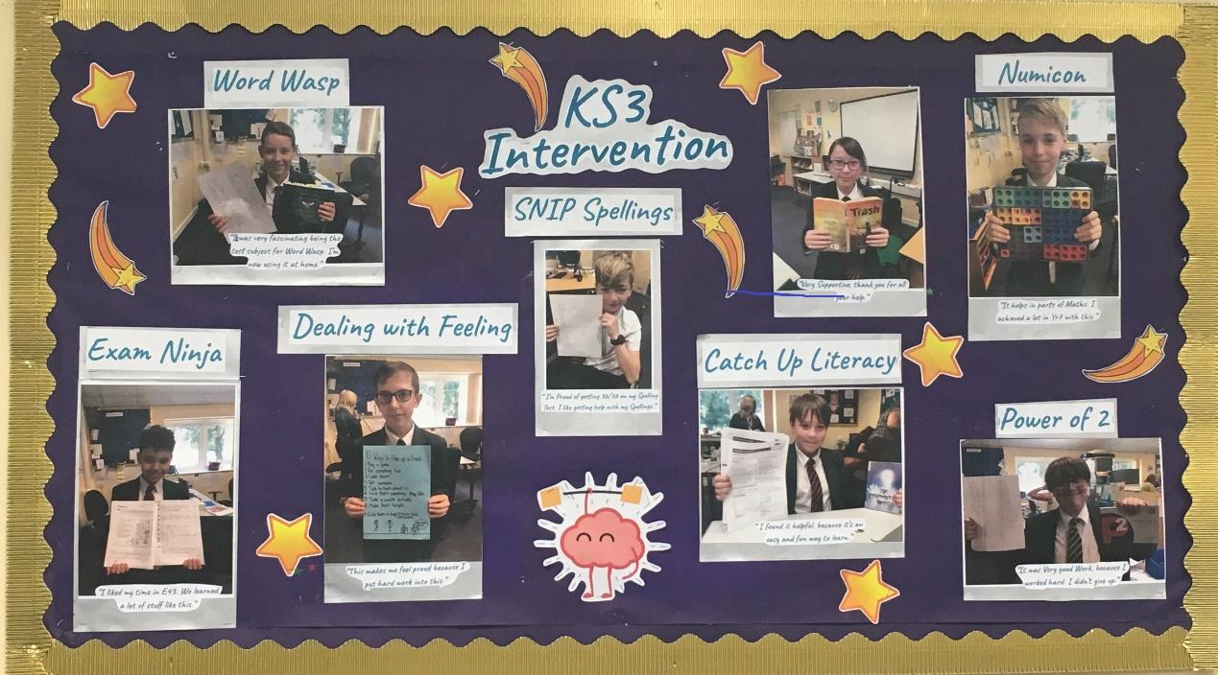

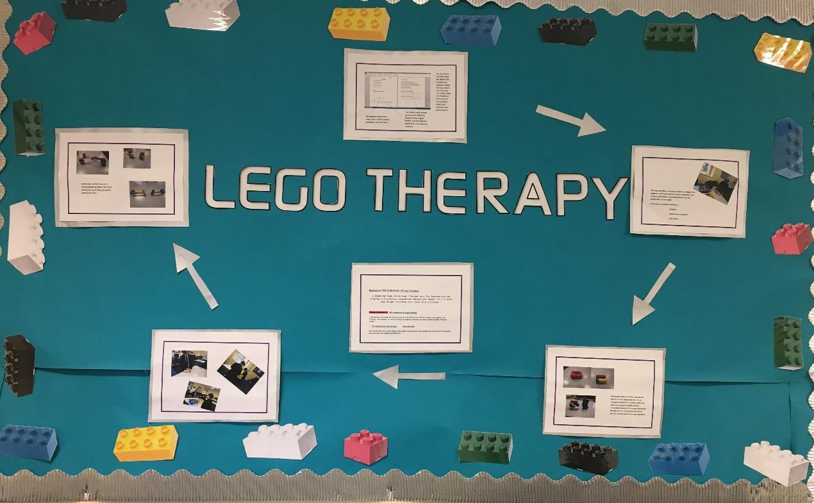

How does the academy enable pupils with SEND to engage together with children without SEND? (clause 3f)

Broadland High Ormiston Academy uses its best endeavours to make reasonable adjustments to promote the inclusion of learners with SEND compared to those without. We offer different levels of in class support, therapies, specialist equipment and adaptations to the physical environment using a child centred approach. Further details can be found in our Accessibility Plan available at:-

http://www.broadlandhighoa.co.uk/our-school/policies/

All our extra-curricular activities and school visits are available to all our students. Equally we encourage all our students to go on residential trips and will work closely with parents to identify and remove any possible barriers to inclusion. We also encourage all our pupils’ irrespective of any special needs to take part in the leadership opportunities available throughout our academy. We use our best endeavours to ensure that pupils with SEND are equally represented amongst our form captains, sports leaders, members of parliament or prefects.

What support is available to improve the social, emotional and mental health of our pupils? (clause 3g)

In addition to our pupils following a dedicated personal, social and health education curriculum we ensure that key members of our pastoral/SEN team attend appropriate development opportunities/courses to enable them to offer further support to our learners that need it. At break and lunch time additional adult support is available in the learning support room. This provision is aimed at pupils that need help in either managing anxiety, developing appropriate social, communication and interaction skills or resolving any issues that arise with their peers. Alternatively, support is also available from the student support centre/safe space.

Our learners also have access to the services of two qualified counsellors, Charlotte Darley and Jo Reading.

What arrangements do we have in place for consulting and involving parents and young people on the SEN provision in place? (clause 7 and 8)

Parents and Pupils are encouraged to make contact with the learning support department/SENCo immediately they have any concerns or need any advice and guidance on whole academy or SEND related issues. This can be done by way of a written note in the child’s planner or by using the contact details at the beginning of this report. Equally teachers and Heads of Department/Year can be contacted on an everyday basis by telephoning or emailing the academy office. Each year group will also have a ‘Pastoral and Progress Manager’ that is a non-teaching member of staff and so can be contacted more quickly.

In addition to the twice-yearly written report and annual parent/teacher consultation evening pupils with special educational needs have a termly provision review meeting or conversation. These meetings/conversations are also an important part of the graduated provision where progress is discussed against desired outcomes and the decision as whether the child still needs to receive SEN support is jointly made. For a child with an Education, Health and Care Plan progress is reported to the Local Authority by way of the annual review during which a recommendation is made as to whether the plan should be ceased or not.

At various stages during the year, both pupils and parents are asked to complete questionnaires on their views prior to review meetings whether these are for children at SEN support or those that have an EHCP.

The academy also takes an active role in disseminating any information from either the local authority or outside agencies such ‘Just one Norfolk’ and ‘Norfolk SENDIASS’.

How do we work with external support services to meet the needs of our learners with SEND and to support their families? (clause 10)

Education

Who? | What for?
Ormiston Academies Trust SENCo Network.  Willow Tree Learning. | Sharing of best practice, continuous professional development/networking
The Child and Educational Psychology Practice.  The Educational Psychology and Specialist Support Service. | Specialist and educational psychology advice and assessment.
Access Through Technology | For support, assessment and provision of assistive technology/software.
Medical Needs Team  Short Stay School for Norfolk | Home learning support for students medically unfit for school.
Beacon East | Independent Careers Advice and Guidance.
Virtual School for SEND | Advice, support and challenge. Applications for tier 3 (top up) funding.
Virtual School for Sensory Support | Assessment, advice and guidance for pupil’s with sensory needs.
School to School (S2S) | Support, advice and training from complex needs schools on meeting the needs of learners with SEND
Virtual School for Children in Care | For support, challenge and additional resourcing to in meet the wide ranging needs of children in care

Health

Who? | What for?
ADHD specialist nursing team. | To support both school and families in meeting the needs of children with ADHD including medication review and guidance.
Paediatric diabetes specialist nurses. | To support both school and families in meeting the needs of children with diabetes including training.
CAMHS (Child and Adolescent Mental Health Services)  Point 1  MAP (Mancroft Advice Project) | Mental health advice, diagnosis and direct work with children and their families.
Neurodevelopmental Team | Advice and diagnosis for children showing signs of a neurodevelopmental disorder.
Norfolk Healthy Child Programme (Just One Norfolk) | Clinical advice and information, signposting and referrals to the right health service for children, young people and their families.
East Coast Speech and Language Services | Advice, assessment and speech and language programmes and therapy.
Occupational Health | Advice and recommended reasonable adjustments to policy, practise or premises to promote inclusion for pupils and staff.  Manual Handling training.
Eating Disorders Team | Diagnosis, support and monitoring of children and young people with eating disorders.
Paediatric Physiotherapy Team | Advice, assessment and physiotherapy programmes.

Social Care, Police and Third Sector Organisations

Who? | What for?
Early Help Family Focus | Advice, guidance and support for family difficulties.
Youth Offending Team | To prevent children and young people from offending and to help them restore the damage caused to their victims.
Asperger East Anglia  ASD Helping Hands | Guidance, practical advice and support for everyone with or living/working with a person with an autistic spectrum condition.
About with Friends | Support, activities, guidance and care for people with learning disabilities.
Lola Stafford | Direct work with children to reduce the risk of disengagement and low attainment.
Nelson’s Journey | Support for children and young people up who have experienced the death of a significant person in their life.
Leeway | Support for adults, young people and children who are experiencing domestic abuse.
The Matthew Project | Supporting children and adults with issues around substance misuse and wellbeing.

How do we secure resources to support children and young people with special educational needs? (clause 6)

All pupils have element 1 funding, this is currently around £4800 per term at key stage 3 and £5400 per term at key stage 4. The academy receives an additional sum of money each year from the local authority known as element 2 funding or the notional budget. The amount of funding received by the academy for the 2023.24 financial year is in the region of £200,000.

In addition to the above sum the academy can apply for high needs funding from the LA for all pupils with EHC plans and in cases where there are exceptional needs. This requires an INDES to be filled in, identifying the child’s individual needs and evidence to be submitted. This then goes through a moderation process, where pupils are placed into bands for additional funding.

We anticipate that this academic year we will spend in excess of £200,000 supporting our learners with SEND, this sum includes the cost of learning support staff salaries, training as well as small teaching group provision.

The academy uses its best endeavours to meet a child’s special educational needs with the resources available, which includes using the notional SEND budget directly and to commission support from other professionals. However, if after typically 2 terms of SEN support the desired progress has not been achieved then it may be necessary to make a request to the Local Authority for an Education, Health and Care needs assessment. This may result in an Education, Health and Care Plan (EHCP) being issued. EHCPs are legal documents which set out the outcomes required, and the provision needed to achieve them. Further details on EHCPs and assessments are available at:-

https://www.norfolk.gov.uk/children-and-families/send-local-offer/support-for-learning/education-health-and-care-ehc-plans

What is the expertise and training of our learning support staff? (clause 5)

Our SEND support team are highly committed and skilled practitioners with over 65 years of collective experience supporting vulnerable learners at Broadland High. In addition to our Head of Additional Needs and Assistant Head of Additional needs, we have 2 higher level teaching assistants, a lead learning support assistant, 1 SEND teacher and 4 further LSAs,

Our Head of Additional Needs and SENCo, in addition to being a qualified teacher also holds: -

- The National Award for SEN Coordination.
- DSL – Designated Safeguarding Lead.
- Senior Mental Health Lead.

Our Team

Karen Coe – Assistant Head of Additional Needs and SEND manager.
Martina Walls – HLTA
Lana Debbage - HLTA
Vic Harvey – Lead LSA for Social, emotional and mental health
Rebecca Moran – Qualified teacher in Primary and SEND teacher.
Sharon Andrews - LSA
Mark Lawson – LSA
Elizabeth Craske – LSA
Frances Herbert – LSA

All our support staff have ongoing training and have attended many courses in the last year via the National College and through academy inset. We have also attended specialist training on Tourette’s and Tics, Zones of Regulation and Managing Epilepsy. Three members of our team are about to embark on National Apprenticeships. Another is taking a Level 4 SEMH qualification with Eastern Partnership.

Who can I contact for free and impartial advice? (clause 11)

Advice and support is available from The Norfolk SEND information, Advice and Support Service (IASS) Partnership. They provide Information Booklets, a Help Desk, person-centred support and a face-to-face Advice Clinic.

www.norfolksendpartnershipiass.org.uk

What arrangements do we have to support children with SEND from or to their next stage of education? (clause 12)

Broadland High Ormiston Academy places great importance on supporting all learners with transition. This can be transition from Year 6 to Year 7, moving to a new class in school, having a new teacher, moving to another school, or moving onto to further education, employment and training.

Planning for transition is a key part of our provision for all learners with SEND.
For learners with an EHCP our SENCo, where possible, will attend both their year 5 and 6 reviews so that they can start to build a clear picture of the students’ individual needs. A key transition concern for many students and their parents/ carers surrounds the level of support that will be available at high school. We encourage all parents/ carers to engage with the academy early during the transition process so they can be reassured that their child’s needs will be met. We welcome pre-planned visits at any time and hold our annual open evening in late September each year to which children of any age and their parents are welcome.

Unless parents specifically withdraw consent, a child’s educational record including any SEND information moves with them from school to school. Therefore, parents can be reassured that we will know the full educational history of their child, including previous assessments, plans and interventions that have taken place.

Key information is the written into the child’s SEND support plan which is available electronically to all staff.

We continue to support our learners with SEND with managing change during their time with us, for example if needed, we will arrange meetings with new teachers and offer extra opportunities to visit the school before the term starts, this is especially important after the 6 week summer break.

From Year 9 onwards planning starts for effective transition to post 16 provision, this means that students move onto the next stage in their educational journey successfully and avoid becoming NEET (not in education, employment or training). All students on the SEND register are offered 2 appointments with a specialist independent advice and guidance advisor. The first appointment results in an Action Plan and progress towards the targets set is reviewed and refined in the second appointment.

All students have the opportunity to spend a week on work experience in the summer term of Year 10. We provide extra support for pupils with SEND to ensure a suitable placement is secured and that the employer is aware of the child’s needs.

As part of the planning for post 16 transition we ask for the consent of the young person to share their data with any planned post 16 provider. Following this, conversations/ visits are held to ensure that the new provider is aware of the support needed by the student, including any GCSE access arrangements.

What arrangements do we have for supporting children and young people who are looked after by the local authority (children in care) who also have SEND? (6.80)

Our designated teacher for Looked After Children (LAC)/children in care is Mrs Danielle Connolly Ratcliffe. Mrs Connolly Ratcliffe works closely with Mrs Gilroy as well as the wider staff to promote the educational achievement of looked after children who also have special educational needs. Our approach ensures that we are kept up to date with best practice which is “Attachment Aware” as well as founded upon good teaching. We closely monitor the progress, attendance and exclusions of all our looked after children to ensure they are not over-represented compared to the rest of the academy. When writing and implementing our policies we take into account the differing needs of our children in care, remembering the soundbite that “fair isn’t always equal”.

All children in care have a personal education plan (PEP) which supports progress by identifying areas for improvement and setting specific measurable targets to achieve these. The PEP is reviewed termly in addition to the SEND planning and provision review. Additionally, resources are available by way of the pupil premium plus grant which is managed by the virtual school for LAC. Further details are available in our Looked After Children policy available here: -

http://www.broadlandhighoa.co.uk/our-school/policies/

What do I do if I have a complaint about the special educational needs provision made for my child? (clause 9)

Broadland High Ormiston Academy uses its best endeavours to meet the additional needs of all learners however we recognise that sometimes parents/carers or students may disagree with us. Independent advice and mediation services are available from Norfolk SEND partnership

Step 1: Find out whether you concerns are justified by:-

- Reading this report and our SEND policy.
- Refer to https://www.norfolk.gov.uk/children-and-families/send-local-offer/education-and-training-0-25/special-educational-provision-we-expect
- Refer to https://www.norfolk.gov.uk/children-and-families/send-local-offer/support-for-learning/special-educational-needs-sen-support/help-when-things-go-wrong

Step 2: Talk about your concerns:

- Talk to your child’s subject teacher or form tutor
- Discuss your concerns with the SEN Co-ordinator
- Get free impartial information, advice and support from Norfolk SEND Partnership on 01603 704070
https://www.norfolksendpartnershipiass.org.uk/
- Contact KIDS dispute resolution service T: 03330 062835 E: senmediation@kids.org.uk

Step 3: Follow the academy’s complaint procedure available at:

- http://www.broadlandhighoa.co.uk/our-school/policies/

Have your say.

At Broadland High Ormiston Academy, we are fully committed to working together with all members of our school community. This information report has been produced in conjunction with students, parents/carers, middle and senior leaders and governors. We would welcome your feedback and future involvement in the review of our SEND offer, which takes place annually.

Special Educational Needs and Disability (SEND) Contacts and Responsibilities
This document should be viewed in conjunction with the OAT-SEND-Policy-February-2023.pdf (ormistonswbacademy.org.uk)

Last updated: 06/09/2023

Academy roles
Role | Designated person | Contact Details
SENCO | Eleanor Gilroy | 01603 782715 ext:254  eleanorgilroy@broadlandhighoa.co.uk
Principal | Matthew Sprake | matthewsprake@broadlandhighoa.co.uk
SEND Governor | Paul Middleditch | paulmiddleditch@broadlandhighoa.co.uk
Other senior leader with responsibility for SEND | Danielle Connolly Ratcliffe | danielleconnollyratcliffe@broadlandhighoa.co.uk
Pastoral support lead | Danielle Connolly Ratcliffe | danielleconnollyratcliffe@broadlandhighoa.co.uk
Designated safeguarding lead | Danielle Connolly Ratcliffe | danielleconnollyratcliffe@broadlandhighoa.co.uk
Designated teacher for looked after children | Danielle Connolly Ratcliffe | danielleconnollyratcliffe@broadlandhighoa.co.uk
Mental Health Lead | Eleanor Gilroy | eleanorgilroy@broadlandhighoa.co.uk
Other
External agencies
Role | Information | Contact Details
Educational Psychologist |  | Home - Educational Psychology & Specialist Support (norfolkepss.org.uk)
Local SEND Information & Support Services |  | SEND Local Offer - Norfolk County Council  Norfolk SENDIASS Home Page
Local Authority SEN Team |  | inclusionandsend@norfolk.gov.uk
Behaviour Support Team |  | inclusionandsend@norfolk.gov.uk
Sensory Impairment Service |  | Sensory support services - Norfolk County Council  Voice: 0344 800 8020  Textphone: 0344 800 8011  Fax: 0344 800 8012
IPSEA | Independent Provider of Special education Advice | https://www.ipsea.org.uk/
Council for Disabled Children | Advice & resources for professionals and parents | https://councilfordisabledchildren.org.uk/

