PE Big Picture Doc
Pink= Aesthetics Blue= Rackets Orange =Striking and fielding Red= Athletics Green- Team sports Purple= Health and fitness
*Subject to change due to hall use and if lessons impacted by weather
* Some rotations happen across Autumn and Spring terms due to facilities not being available
 | Autumn | Spring | Summer
Year 7 core | Aesthetics  OAA  Netball  Cross Country - Cardiovascular endurance | Fitness  Football  Basketball | Athletics Track  Athletics Field  Striking & fielding  Tennis
Year 8 core | Aesthetics  Netball  Basketball  Cross Country - Cardiovascular endurance | Fitness  Table Tennis  Rugby  Football | Athletics Track  Athletics Field  Striking & fielding  Tennis
Year 9 core | Netball/ Handball  Basketball  Cross Country - Cardiovascular endurance | Fitness  Table Tennis  Football  Rugby | Sports education unit-Sports leadership / officiating - Peer led  Athletics Track/Field  Striking & fielding  Tennis
Year 10 core | Table Tennis  Netball  Football | Fitness/Testing/ PEP (GSCE)  Basketball | Sports education unit-Sports leadership / officiating - Peer led  Athletics Track/Field  Striking & fielding  Tennis
Year 11 core | Netball  Table tennis  Football  Basketball  Handball  Ultimate frisbee  Volleyball  Fitness | 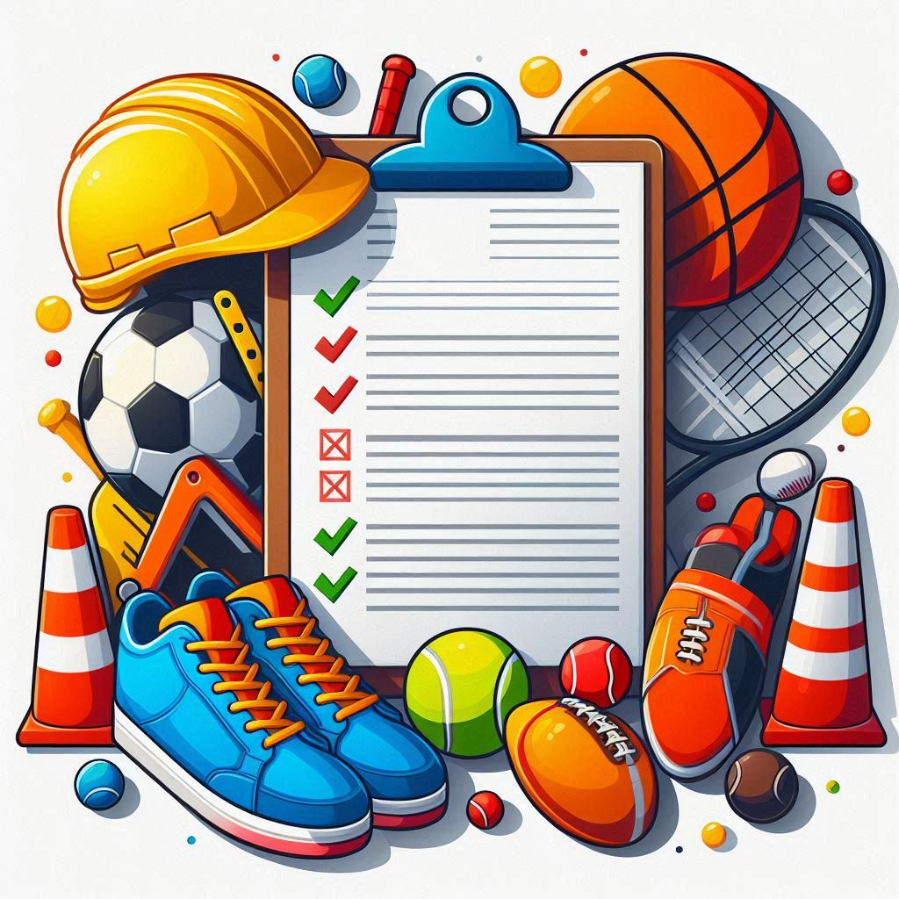 | Year 11 core PE is having a revamp or ‘under construction’. We are looking at the needs of different groups with the aim of introducing some new concepts and sports including Sports Ed units of work, Volleyball, Ultimate frisbee etc. We are looking for the right ‘fit’ for the groups we have each year and will keep adapting to fit the needs of the year group we through the year.  GCSE students will focus of GCSE sports where applicable e.g. Basketball, Netball, Table tennis and Football.
Year 10 GCSE | Physical Training:  -Types of fitness and fitness testing  -Long term effects of exercise  -Warm ups and cool downs  -Sports injuries and how to avoid them  -Different training methods  -Principles of training  -SMART targets | PEP Written & Practical | Health Fitness and Wellbeing:  -Physical, emotional and social health  -Consequences of a sedentary lifestyle  -Diet & maintaining a healthy weight  Socio-cultural influences:  -Participation rates  -Commercialisation  -The role of the media  -Different sporting behaviour
Year 11 GCSE | Applied Anatomy & Physiology:  -Skeletal system  -Muscular system  -Cardiorespiratory system  -Respiratory system  -Aerobic and anaerobic respiration  -The short term effects on the different systems  Winter Assessments | Movement Analysis:  -Levers  -Planes & Axes  Sport Psychology:  -Skill Classification  -Practice Structures  -Guidance  -Feedback  -Mental Preparation  Spring Assessments  Practical Practice | Revision  Final Exams

Links for GCSE PE

Revision and study
https://www.bbc.co.uk/bitesize/examspecs/zxbg39q

https://senecalearning.com/en-gb/blog/free-edexcel-pe-gcse-revision/

https://www.youtube.com/playlist?list=PLbSSB3KdvkRLINppczg6TQJPbQ-WIlkWj
See PE Planet on YouTube- Check for Edexcel exam board

GCSE PE Overall specification
https://qualifications.pearson.com/content/dam/pdf/GCSE/Physical%20Education/2016/Specification%20and%20sample%20assessments/GCSE-physical-education-2016-specification.pdf

Practical assessment criteria https://qualifications.pearson.com/content/dam/pdf/GCSE/Physical%20Education/2016/Specification%20and%20sample%20assessments/9781446933794-gcse016-l2-pe-ppac.pdf

