Broadland High Ormiston Academy
Assessment and Reporting Policy

Aims:

- to provide reliable summative assessments to share with students, parents, SLT and governors.
- to ensure that students are clear about how to improve, so they make excellent progress and are fully prepared for examinations in year 11 and further study post-16.
- to ensure that factual /literacy errors and poor effort / presentation are corrected.
- to ensure teachers have effective formative assessment strategies in place to allow for responsive planning and teaching.

Subject Autonomy

It is a key principle of this policy that different subjects will have different approaches to assessment. Each department will set out their own policy, following the guidance below. Department policies will be subject to ratification by the leadership team, to ensure that they are rigorous and effective.

Progression

Each subject will set out the knowledge and skills students will develop through their 5 years at Broadland, and will share common student errors and misconceptions as a team in order to make planning and formative assessment more effective in dealing with them.

Summative Assessment

Summative assessment must provide some shared meaning for students, staff, parents and governors, so it must be reliable, by which we mean that pupils should achieve roughly the same mark regardless of other factors, for example who marks it or what time of day it is done. It is important to distinguish between performance, which may be fleeting, and true learning, which implies a change in long term memory.

In each subject area, a range of tools may be used for summative assessment. Each subject must explain how they will assess the knowledge and skills identified as key to progression. In most subject areas this will take the form of a twice-yearly examination, though there will be flexibility where this is not the most effective method.

Summative assessments must sample from a wide domain of content taught both in that year and previous years, and may include different kinds of tasks, for example multiple choice, short answer and essay questions. A general principle is that students should only be assessed on the curriculum they have been taught, but at KS4 there may be occasions where past papers (used to provide a comparable, standardised grade across the trust) could include material that is still to be taught. In these cases, teachers will explain this and take it into account when arriving at PPGs.

At KS3 subjects will provide a percentage score at each assessment point. At KS4 GCSE grades will be used and subjects will provide both an exam result and a Professional Predicted Grade (PPG), which is the teacher’s best estimate of the likely grade which will be achieved at the end of the course. PPGs will be fine graded to reflect the confidence level of the teacher (+ = completely secure, could achieve next grade up; no modifier = secure; - = wobbly, may need intervention).

Formative Assessment

Formative assessment must provide useful, actionable information for staff or students. This might take the form of written or verbal feedback, or simply amended lesson plans on the part of the teacher. If we try to use it for summative purposes (e.g. tracking) we compromise it, because the skills and knowledge students need to practise in order to improve and build towards a better outcome on the final summative assessment are not necessarily the same as those it will test.

Effective formative assessment depends upon teachers’ pedagogical subject knowledge: each team must know the common misconceptions students bring to each topic or unit of work and the errors they tend to make. This means teachers can plan to deal with these mistakes / misconceptions, and check for them diagnostically with formative assessment.

Each subject area will set out how assessment will be used:

- to check on students’ understanding;
- as retrieval practice to improve memory;
- to check on study;
- to correct factual and literacy errors / poor effort (and reward good effort).

Different subject areas lend themselves to different forms of assessment. Providing there is a strong rationale for the tools selected, departments may use different methods and tools, for example:

- questioning and verbal feedback in class
- low stakes/no stakes quizzing/testing
- sampling some students’ classwork without marking it, in order to inform planning
- multiple choice questions and automatic feedback / Question level analysis
- marking against a rubric
- self and peer assessment

Each subject area will define in their own policy when these techniques should be used and the frequency. Heads of department will set out what data will be collected at a departmental level and its purpose, for example to identify units or topics where students have underperformed generally which may require different resources or joint planning.

Feeding back to students

Feedback has been shown to have a significant impact on the progress made by students over time. However, this does not necessarily mean individual written feedback. Each subject area will have its own approach to feedback, set out within the department policy. A range of methods may be used, and the head of department must choose those which have the greatest impact. Teachers have a finite amount of time for planning, preparation and assessment and therefore the most efficient methods should be chosen where they provide the teacher or the student with the key information they need to enable excellent progress to be made. This is likely to mean less written feedback in exercise books / folders.

Some of the methods of feeding back available are:

- Verbally
- Using codes
- Using criteria checklists
- Using class feedback sheets and feeding back to the whole group
- Using extended written feedback on student work
- Using question level analysis/automatic feedback on multiple choice questions

There should be opportunities for students to act on feedback received in order to make further progress.

Reporting to Parents

Teachers must provide a summative grade for each child to the whole school system twice a year. This will be used for tracking, for reporting to parents and to governors. Detailed attitude to learning grades (see appendix 1) will also be collected for the same purposes. Written comments will no longer be part of reports to parents because their limited impact on learning does not justify the amount of time teachers, the leadership team and administrative staff spend on producing them. The time saved will be re-focussed on responsive teaching built on high quality assessment and planning.

Quality Assurance

Each head of department will include in their policy information on how they will ensure summative assessments are reliable and how they will quality assure formative assessment in their subject area(s). Each department will design their own work scrutiny proforma (subject to SLT approval) to ensure the implementation of the policy can be monitored both at a departmental and whole school level for consistency. Any evidence should be useful in itself, not created purely for monitoring.

Review

This policy will be reviewed annually by SLT and governors in the light of any new research evidence and following evaluation with Heads of Department.

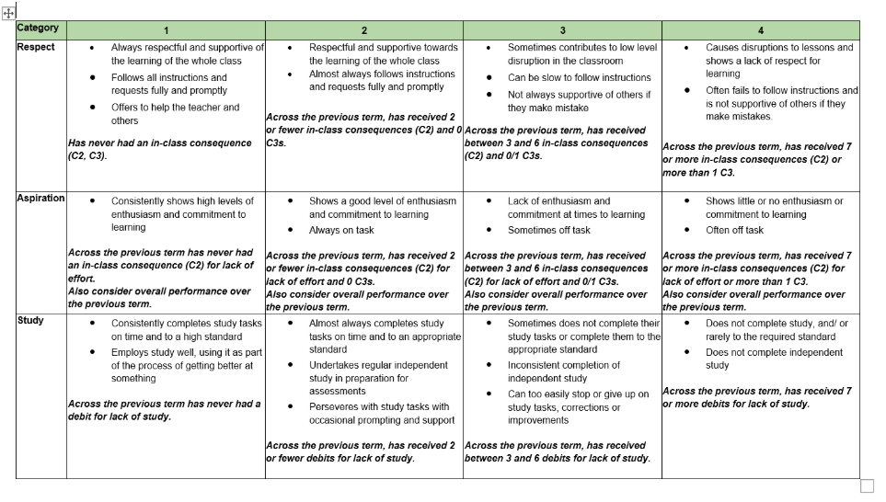
Appendix i - Attitude to Learning Grades

