Broadland High Ormiston Academy Uniform Policy

Aims:
- To unify our students in a smart collective dress code.
- To create a shared identity based around pride in attending Broadland High.
- To ensure our students are ‘ready to learn’ and not distracted by clothing.
- To avoid inappropriate clothing on the academy site.
- To avoid discrimination based on clothing or fashion.
- To reduce pressure on parents to buy the latest fashions.
- To prepare students for the uniformed world of work.

Academy Uniform Overview
We believe that it is important for all our students to maintain a smart appearance in our academy.
We therefore expect all students to adhere to the following dress code. In instances where the Academy dress code is not adhered to, the behaviour policy will be followed.

Uniform Item | Expectation | Additional Information
Blazer | KS3 - Green blazer with academy badge  KS4 - Black blazer with academy badge | - Only academy issued badges to be worn on blazers e.g. Prefect badge  - Blazers are to be worn at all times and should only be removed with the permission of the teacher  - Blazers can be removed whilst playing on the hardcourts/field during breaktime and lunchtime, and should be put back on before leaving that area
Jumper  (Optional) | KS3 - Green V neck  KS4 - Black V neck  (The badged jumper is advised) | - Should only be worn under the blazer  - Should not be worn instead of the blazer
White Shirt | With collar and top button | - Top button fastened at all times  - Short sleeved shirts can be worn in the summer  - Long enough to be tucked in properly at all times  - Plain (no frills or logos)
Tie | Year group striped tie | - Length of x12 stripes visible  - Ties that have been drawn on, coloured in or vandalised will need to be replaced.
Footwear | Plain black leather or synthetic leather footwear | - Students are allowed to wear black, leather (or synthetic leather) footwear with black soles and no other evident colours, markings or visible branding.  - No boots unless extenuating circumstances linked to injury or support have been agreed  - Footwear should be polished  - No coloured logos, edging or laces  - No heels
Coat  (Optional) | Suitable and appropriate coat | - Should not be worn under or in place of the blazer  - No ‘hoodies’ or non-academy jumpers at any time
Jewellery | Watch (Not a Smartwatch)  One stud per ear | - No facial/body piercings (a clear plastic retainer may be worn in place of a nose piercing)  - No body artistry (includes Henna and drawing on hands/ arms)  - No rings, necklaces or bracelets (medical alert items are permitted)
Trousers | Black or charcoal grey trousers  (The badged trousers are strongly advised) | - Straight, bootleg or wide leg trousers only  - No ‘skinny’ trousers, chinos, cropped, canvas or jean materials  - No visible zips or rivets  - It is strongly advised that the ‘badged’ trouser is purchased. This can be purchased from Birds of Dereham
Shorts | Black or charcoal grey tailored shorts | - Knee-length tailored smart shorts in black  - Any belt worn must pass through loops and be plain black  - No cargo style shorts  - No logos or visible branding  - No cycling shorts, sports/ PE shorts or short/ tight shorts are to be worn  - The recommended Birds of Dereham shorts can be found here.
Belt  (Optional) | Dark plain belt | - No brightly coloured belts  - Small buckle with no logos
Socks | Dark socks (Black or charcoal grey) | - No patterns or logos
Skirt | Black knee length pleated skirt.  (The badged skirt is advised) | - Skirts must be no more than one hands width above the knee, ideally worn on the knee  - Skirts must be fully pleated  - Skirts must not be straight, skinny, tight Lycra or made of stretchy material – they must be pleated  - It is strongly advised that the ‘badged’ skirt is purchased. This can be purchased from Birds of Dereham
Tights | Plain black or flesh coloured
Makeup and Nails | Makeup should be of a natural colour | - Clear nail varnish only  - Nails should be of a sensible length  - No false/ gel or acrylic nails

Physical Education
Black polo shirt with academy logo |  | In addition, optional items:
Mid-thigh length black sports shorts or black sports tights. |  | Black tracksuit bottoms (optional for when the weather is cold)
White sports socks for indoors
Black football socks for outdoors
Trainers – we do not use our school footwear |  | Black BHOA sweatshirt with Academy logo for cold weather
Football boots |  | Black BHOA sweatshirt with Academy logo for cold weather
Shin pads |  | BHOA reversible rugby shirt
Gum shields are recommended for hockey and compulsory for contact rugby |  | BHOA reversible rugby shirt
Drama: Grip socks to change into

- All articles of clothing and personal belongings must be clearly named
- Ties can be purchased from the Broadland High academy office

Birds of Dereham
UNIT D 13 YAXHAM ROAD, DEREHAM, NORFOLK NR19 1HB. enquiries@birdsofdereham.com
+44 (0) 1362 692941 +44 (0) 1362 699130

Electronic devices not permitted in school:
Mobile phones, smart watches, headphones, speakers and MP3 players are not allowed to be seen on the academy site (NB: the academy does not take any responsibility for such items). They may be used on the way to and from the academy but must be turned off and put away in bags before the student enters the site and must not be taken out until the student has left the academy site.

Further information and guidance:

Shoes:
- Students are allowed to wear black, leather or synthetic leather footwear with black soles and no other evident colours, markings or visible branding. (No coloured logos or edging).
- No heels

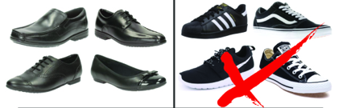

Skirts:
- Skirts must be no more than 12cm above the knee
- Fully pleated
- Skirts must not be straight, skinny, tight Lycra or made of stretchy material
- It is strongly advised that the ‘badged’ skirt is purchased. This can be purchased from Birds of Dereham

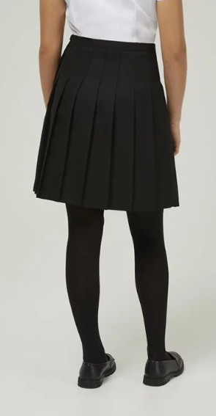
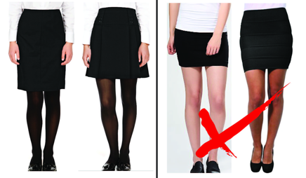
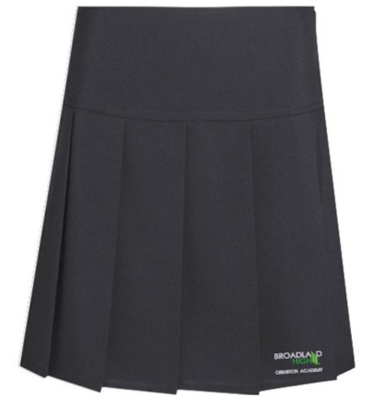

Trousers:
- Straight, bootleg or wide leg trousers only
- No ‘skinny’ trousers, cropped trousers, chinos, canvas or jean materials
- No visible zips or rivets
- It is advised that the ‘badged’ trouser is purchased. This can be purchased from Birds of Dereham
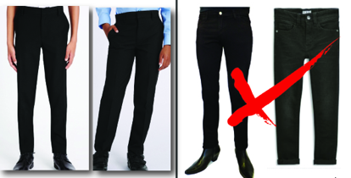

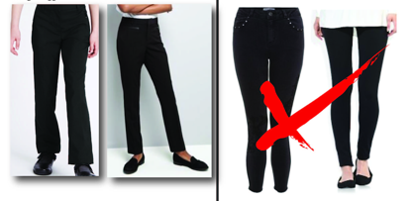

Uniform Routines:

Uniform is checked every morning at lineups.

Students with incorrect uniform will be taken by PPMs to correct this, for example to replace white socks with black socks. Or contact parent/ carers to being in correct uniform item. In instances where students will not correct uniform, they will work in internal suspension until this is corrected.

Where students have chosen to have new piercings or where false and acrylic nails have been applied and cannot be removed, students will work in internal suspension until this is corrected.

When transitioning around the academy, we expect students to where their uniform correctly. Staff will issue uniform consequences for students which will generate a 20-minute detention where this is not the case.

Equipment:
In addition to their academy uniform, we expect all students to be well prepared for learning and arrive to all their lessons with a set of basic classroom equipment that should consist of:
- Pencil case
- 2 pens
- Pencil
- Ruler
- Rubber
- Scientific calculator
- Protractor
- Glue stick
- Green pen
- Highlighter
- Reading book (Available from library or supplied from home)
- Planner (Supplied by academy)
- Study Folder (Supplied by academy)

- Please do not pack scissors in pencil cases as they can be considered a dangerous item. Scissors will be provided in lessons when required.

Equipment Routines:

Equipment is checked every morning during tutor time. This ensures there is no disruption to lessons due to lack of equipment.
Students with a lack of equipment will be provided equipment by their tutor. They will also be issued with a lack of equipment consequence which will result in a 20-minute detention at lunchtime. Please contact the school where issues with equipment exist to ensure we can support all students to have the correct equipment.
Heads of Year will contact parents/ carers to support with persistent breaches of the equipment expectations.

