

Broadland High Ormiston Academy
Accessibility Plan
Date adopted: February 2024 Next review date: February 2029
Policy Version Control

Policy Prepared by | OAT Mandatory Policy
Responsible Committee | LGB
Description of Changes | Academy produced policy
Signed | 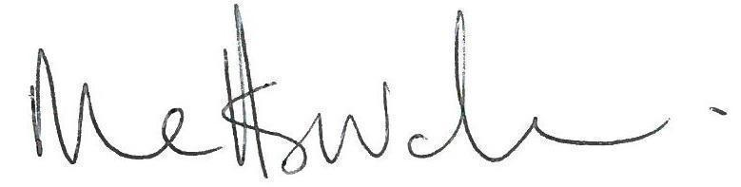  24.06.2026

Statement of intent
This plan outlines the proposals of the governing body of Broadland High Ormiston Academy to increase access to education for pupils with disabilities in the three areas required by the planning duties in the Equality Act 2010. These include:
- Increasing the extent to which pupils with disabilities can participate in the academy curriculum.
- Improving the environment of the academy to increase the extent to which pupils with disabilities can take advantage of education and associated services.
- Improving information delivery to pupils with disabilities which is readily available to other pupils.
The above procedures will be delivered within a reasonable time, and in ways which are determined after taking in to account the pupil’s disabilities and the views of the parents/carers and pupil.
In the preparation of an accessibility strategy, the LA must have regard to the need to allocate adequate resources in the implementation of the strategy.
The governing body also recognises its responsibilities towards employees with disabilities and will:
- Monitor recruitment procedures to ensure that persons with disabilities are provided with equal opportunities.
- Provide appropriate support and provision for employees with disabilities to ensure that they can carry out their work effectively without barriers.
- Undertake reasonable adjustments to enable staff to access the workplace.
- Ensure all staff are trained in equality issues with reference to the Equality Act 2010, including understanding disability issues. The plan will be resourced, implemented, reviewed and revised in consultation with the:
- Parents of pupils
- Principal and other relevant members of staff
- Governors
- External partners

Signed by:
Mr Matthew Sprake (Principal) Date: February 2024

Mr P Middleditch (Chair of governors) Date: February 2024

Aim | Current Good Practice | Objectives | Actions to be taken | Person Responsible | Complete actions by | Success Criteria
Increase access to the curriculum for pupils with a disability | - Adapted curriculum and pathways designed to meet needs for all students, with bespoke packages including study support, y7/8 literacy curriculum, Alternative Provision, intervention and tutoring. Pathways and packages are reviewed regularly and adapted to meet emerging needs.  - Teachers receive CPD and guidance to adapt T&L to meet the needs of students with a range of needs  - Curriculum progress is tracked for all students, including students with a disability, and this analysis and evaluation directly informs decisions about curriculum and pathways adaptations.  - Curriculum pathways at KS4 are flexible and tailored to student need  - Facilities, rooming arrangements, timetables, and resources enable access for all students to all curriculum subjects.  - Enrichment activities including DofE actively adapted to enable access for students with disabilities  - Curriculum content promotes students' knowledge of issues around disability such as through the PSHE and SMSC curriculum | Continued development of alternative provision opportunities in line with AIDP. | See AIDP | VP Curriculum | Sept 2024 | Range of AP provision available.
 |  | Increase engagement with enrichment from students, including students with disabilities | Continued steps to broaden engagement with enrichment programme  Wider range of opportunities provided  Effective tracking system in place to monitor engagement of groups of students. | AHT Enrichment | Sept 2024 | Increased attendance from students with SEND
 |  | Teacher knowledge and practice of pedagogy to meet needs of students with a range of needs | All communication passports kept up to date with key ways teachers can support students | SENCO and team | Sept 2024 | Passports updated regularly
 |  |  | Ongoing CPD on responsive teaching | AHT Director for T&L, with FL for Alternative Learning | Sept 2024 | Staff confidence with pedagogical approaches
Improve and maintain access to the physical environment | The environment is adapted to the needs of pupils as required.  This includes:  - Ramps  - Elevators  - Corridor width  - Disabled parking bays  - Disabled toilets and changing facilities  - Hoist available for use within the Pool including wheelchair friendly changing facilities.  - TA support (when necessary) | To ensure all areas of the academy are accessible to all students, staff and visitors and that all are able to access equipment/ machinery etc. | F block main entrance: Install overhead mechanically operated doors with push pad in and out.  Student services entrance - ensure new doors are accessible for wheelchair users  A block double entrances to be levelled to allow easy access and egress from the block to other learning areas. | Ben Edwards – Site management | Works will be phased across 2 years commencing September 2024 to 2025 manage costs. | Works to be included in Premises Development Plan (PDP)  Any other adjustments required will be made as required.

